|  |  |
| --- | --- |
| 4Culture Logo, which is the number four in black, stylized as a cutout with a black shadow extruding backwards. | 101 PREFONTAINE PL S  SEATTLE, WA 98104  **4CULTURE.ORG** |

**Launch Applicant Companion Guide |** NEW ORGANIZATIONS

This document is intended to be used as a tool as you work on your 2025 Launch application. It includes:

* A step-by-step guide to submitting your application materials
* All of the questions you will be asked in the Launch Inquiry Form and Full Application to assist you in drafting your narrative responses and budget
* Tips from 4Culture staff on how to put together a strong submission
* Links to other resources and information about support available to Launch applicants
* Details on what to expect after you submit your application

The information in this document is tailored to applicants applying to Launch as a **New Organization**. If you want to apply as an Emerging Organization, please refer to the guide for Emerging Organizations available on 4Culture's website; the application questions and requirements for New and Emerging Organizations are slightly different.

Please read the [**Launch Grant Guidelines**](https://www.4culture.org/grants/launch/) thoroughly before applying. We recommend reviewing the grant review criteria while you’re working on your application. You may also benefit from reviewing our [**guide for Launch applicants applying with fiscal sponsors**](https://bit.ly/4claunchfiscalsponsorship) and our [**Glossary of 4Culture and Nonprofit Jargon**](https://bit.ly/4candnonprofitjargon).

**All Inquiry Forms and Full Applications must be submitted ONLINE at** [**www.apply.4culture.org**](http://www.apply.4culture.org) **by their respective deadlines. No extensions will be granted.** Using this document is not required, nor is it an acceptable alternative to the online forms.

**4Culture is here to help!** We’d love to hear from you. If you have any questions about Launch grants or this document, please contact Casey Moser, Launch Program Manager, at [**casey.moser@4culture.org**](mailto:casey.moser@4culture.org) or Maisha Barnett, Support Specialist, at [**maisha.barnett@4culture.org**](mailto:Maisha.barnett@4culture.org).

**Table of Contents**

The Application Process and Applicant Supports 3

Overview of Application Steps and Checklist 3

Helpful Tips for Applicants 4

Get Support Completing Your Application 4

A Step-by-Step Guide to Applying for Launch Funding 6

Step 1: Setting Up an Account on 4Culture’s Grant Portal 6

Step 2: Completing the Inquiry Form 10

Worksheet: Launch Inquiry Form 13

Step 3: Completing the Full Application for New Organizations 20

Worksheet: Launch Full Application 24

Step 4: Completing Your 2025 Demographic Information 32

Step 5: Filling Out Your Previous Year Financial Information 35

What to Expect After You Submit Your Application 37

Initial Review 37

Peer Review Panel & Funding Decisions 37

Committee Review & Board Approval 37

Notification 37

# **The Application Process and Applicant Supports**

## Application Checklist

There are five steps to apply for a Launch grant. **You must complete all of these steps** **to be considered for this grant.**

* **Request an organization account on 4Culture’s grant portal and complete your Account Profile no later than 5 pm PDT on Wednesday, August 13, 2025.** If you have applied for a 4Culture grant before, confirm that you still have log-in access and that your organization has answered all the questions under “Organization Accounts Only”.  
    
  You can create an account at any time, and your profile must be complete prior to submitting the Launch Inquiry Form in Step 2. Use this link to request an account, and please note that it can take up to two (2) business days for your account to be active:
* **Submit the Inquiry Form via the online form no later than 5pm PDT on Wednesday, August 13, 2025.** 4Culture staff will review this form to confirm your eligibility for a Launch grant. If you are eligible, 4Culture staff will send you instructions on how to access and complete the full application.
* **Submit the full Application on the online grant portal no later than 5pm PDT on Wednesday, August 27, 2025.** This application is what will be reviewed by the peer panel making grant decisions.
* **Submit your organization’s 2025 demographic information no later than 5 pm PDT on Wednesday, August 27, 2025.** Information about our applicants is used by 4Culture to help us understand who we serve and how we can increase program access for all King County residents and communities. Your specific answers cannot be seen by program managers or review panels and will not affect funding decisions.
* **If your organization has previous year(s) of financial information for 2023 and/or 2024, please enter it in your account profile no later than 5 pm PDT on Wednesday, August 27, 2025**. Organizations will need to enter actual income and expenditure information for previous years of operation, if applicable.

A step-by-step guide to completing each of these five (5) steps is included in the following pages.

## Helpful Tips for Applicants

* Not sure if your organization meets the eligibility criteria? **Please contact 4Culture to confirm your eligibility BEFORE applying.**
* Start early! Give yourself the time you need. **We recommend starting your application at least 3 weeks before the deadline.**
* **Work offline and save often.** **The application portal will not save automatically.** Saving your work in Word or Google Docs will ensure that an internet outage won’t result in lost work. You can also keep track of your word count and spelling this way. If you get an error when saving after you cut and paste text from your document, it could be due to hidden characters in the text. Try typing it out or pasting as plain text instead.
* **The word count is just a suggestion.** The system will not cut you off. A bit more or a bit less is fine.
* Having a hard time writing about your group? Try talking about it! Record yourself talking about your organization’s mission and vision as if you were explaining it to a friend. Watch it back and write down what you said. Making a written pitch for your group can be intimidating but **conveying your passion is important.**
* **Ask someone you trust to read your application** and provide feedback.
* **You’re not in this alone – 4Culture is here to help!** We’d love to hear from you. If you have any questions about Launch grants or this document, please contact Casey Moser, Launch Program Manager, at [**casey.moser@4culture.org**](mailto:casey.moser@4culture.org) or Maisha Barnett, Support Specialist, at [**maisha.barnett@4culture.org**](mailto:Maisha.barnett@4culture.org).

## Get Support Completing Your Application

* **Participate in a grant workshop:** Workshops can make a major difference in how competitive an application is. They provide a free, informal opportunity for applicants to meet staff, learn about the process, meet other applicants, and ask questions. View dates, times, and locations and register for your preferred date at [**https:// 4culture.org/grants/launch**](https://www.4culture.org/grants/launch/) under “3. Helping You Succeed”.
* **Attend a Lunch & Learn on topics in nonprofit management:** 4Culture is organizing several free lunch & learn events on nonprofit management topics that will be most relevant to Launch applicants as they are drafting their applications.
  + Introduction to Board Development:
  + Introduction to Grant Writing
  + Introduction to Hiring Your First Staff Member

View dates, times, and locations and register for your preferred lunch & learn events at [**https:// 4culture.org/grants/launch**](https://www.4culture.org/grants/launch/) under “3. Helping You Succeed”.

* **Talk to a consultant:** 4Culture has engaged consultants with expertise in grant writing, budgeting, and organizational development. Applicants whose eligibility has been verified by submitting the Inquiry Form and who have less experience in these areas may work with these consultants to help them put together their application. Learn more about our consultants, their role in the application process, and how to get connected with this support under “Helping You Succeed” at [**www.4culture.org/grants/launch**](http://www.4culture.org/grants/launch)
* **Get Translation Assistance:** 4Culture staff can help secure translation services and translated materials if you communicate best in a language other than English. Please reach out to [**casey.moser@4culture.org**](mailto:casey.moser@4culture.org) for assistance.
* **Reach out to 4Culture:** We are here to help! Send us an email, give us a call, or attend drop-in office hours for grant questions.

For questions about this application, the panel review process, or eligibility:

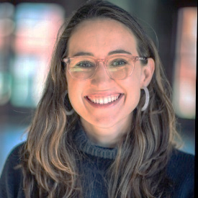

Casey Moser, Launch Program Manager

[**casey.moser@4culture.org**](mailto:casey.moser@4culture.org) or 206-477-2316

For technical questions about your online account or general Launch questions:

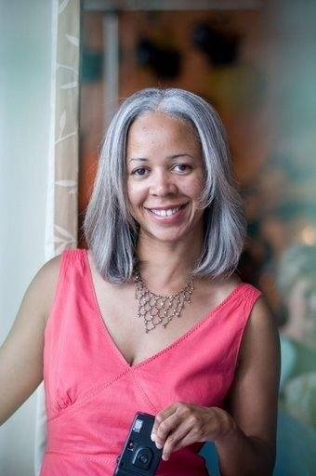

Maisha Barnett, Support Specialist

[**maisha.barnett@4culture.org**](mailto:maisha.barnett@4culture.org) or 206-477-9877

* **Attend Office Hours:** Office hours are unstructured time where staff will be available to answer questions about Launch grants. You can drop-in at any point during the meeting and stick around to hear other applicants' questions or leave once your question is answered. View dates and times and register to get the Zoom link at [**https:// 4culture.org/grants/launch**](https://www.4culture.org/grants/launch/) under “3. Helping You Succeed”.

# **A Step-by-Step Guide to Applying for Launch Funding**

## Step 1: Setting Up an Account on 4Culture’s Grant Portal

1. Go to [**apply.4culture.org**](http://www.apply.4culture.org/)**.**

If you already have an account with 4Culture, check that your login information is working by clicking "Sign In".   
  
If you do not have an existing account with 4Culture, request to create an account. **This can take up to 2 business days.** Someone from 4Culture will contact you once your account is set up with instructions on how to log in.  
  
If you have previously applied to 4Culture as an individual and are now representing an organization, you'll need to request a new organization account with a new email address that can be associated with your role at the organization.

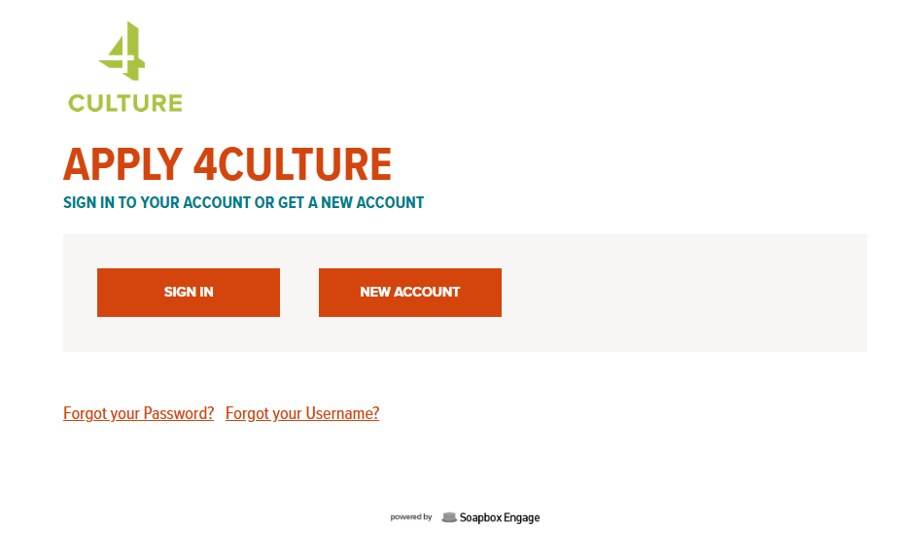

1. If you are requesting a new account, fill out the form that appears after you hit "New Account".   
     
   You must apply for Launch under an **Organization Account.**  
   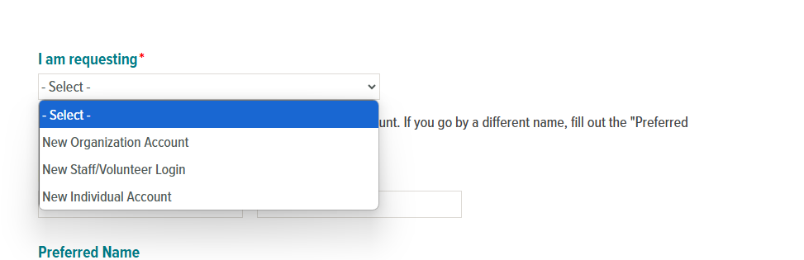
2. Once you’re logged in, click Update your Account and Personal Profile.

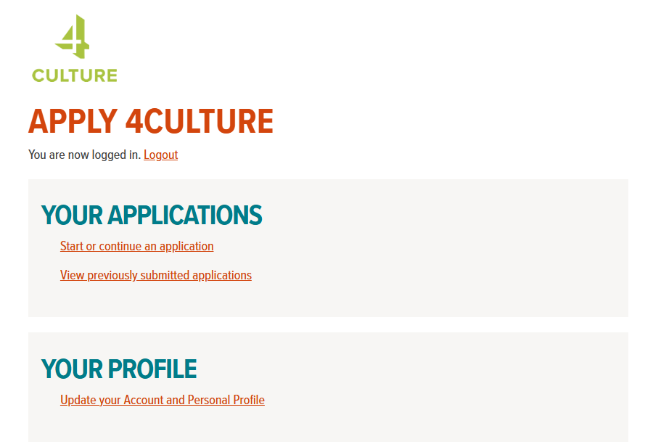

1. Click "View/Edit" under "Your Personal Profile" to check that the your personal information is correct. Add any additional information that was not requested to set up your account (preferred name, job title, etc.).

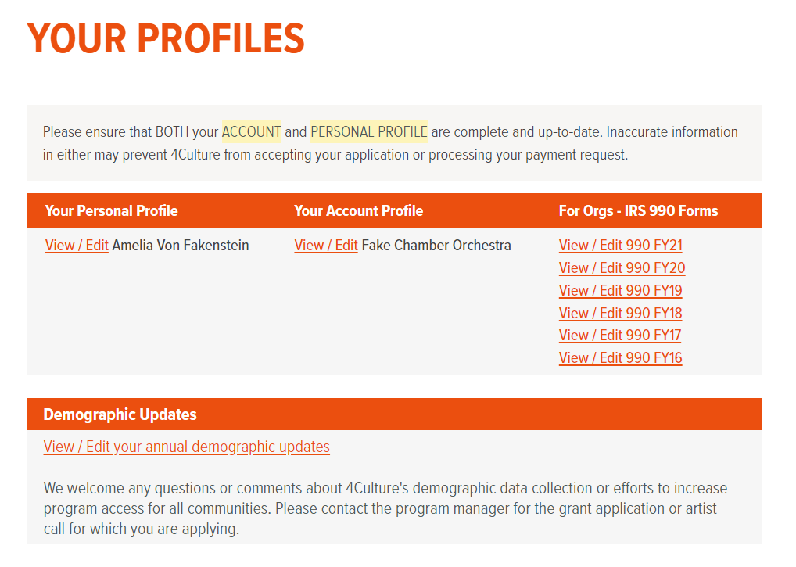

1. Click "View/Edit" under "Your Account Profile" to check that the rest of the information associated with your account is correct for your group.  
     
   Certain information may not be editable; if you need to make an update to a field that you cannot modify, please contact 4Culture.  
     
   
2. Update your Organization Account Profile**.** Make sure you have filled out everything that is applicable under “Organization Accounts only”; your account is not complete without these updates.

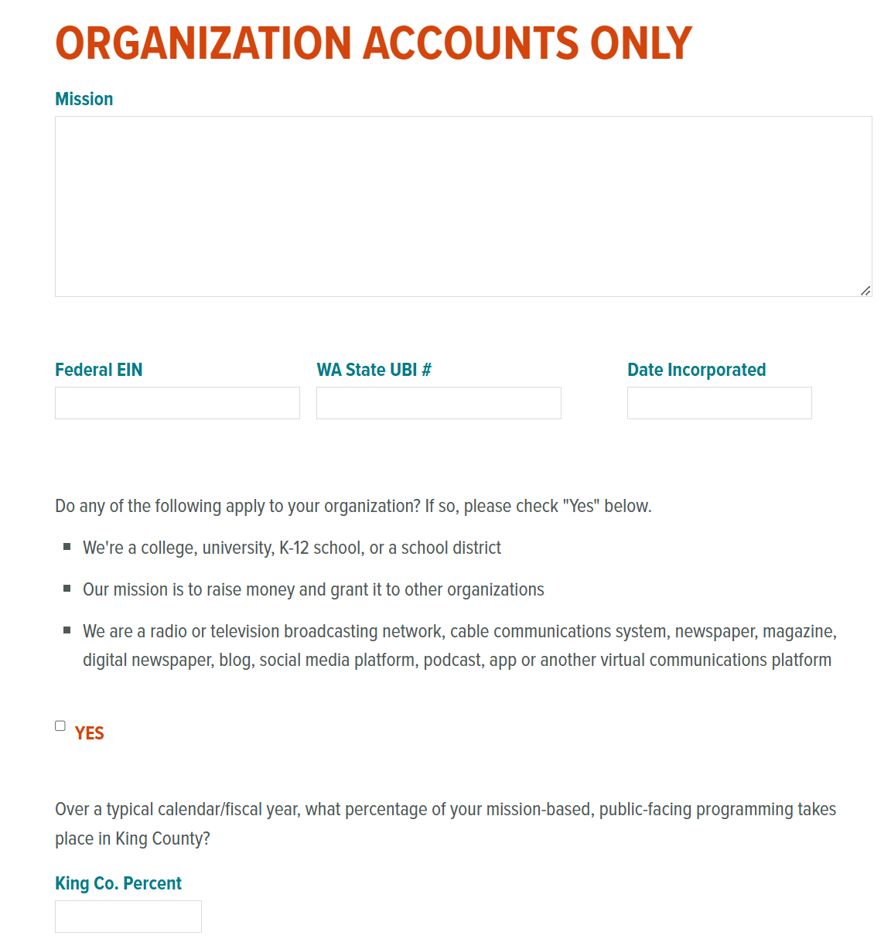

Required information for Launch applicants:

* + **Mission:** a brief description of an organization's purpose, who it serves, and how it serves them.
  + **Federal EIN:** a unique number that identifies the organization to the Internal Revenue Service (if you don’t have one, write “n/a”; if you have a fiscal sponsor, include their EIN).
  + **WA State UBI:** a number used by Washington State to distinctly identify a legal entity (if you don’t have one, write “n/a”; do not put in your fiscal sponsor’s UBI)
  + **Date Incorporated:** The date of formation when you incorporated with the state (if you have not yet formally incorporated, write “n/a”).
  + **King County Percentage:** How much of your programming has taken place or will take place in King County?

Additionally, if your organization is a school, grantmaker, or media organization, please check “YES” in that section of your account profile.

1. Click the orange “Save” button at the bottom of the page once you’re done to add the information to your account.  
   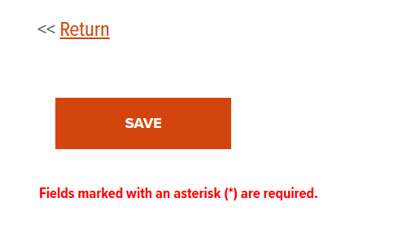
2. Congratulations! Your account is set up and ready to use.   
     
   Please ensure that **both** your Account and Personal Profile are complete and up to date going forward. Inaccurate or out-of-date information in either may prevent 4Culture from accepting your application or processing your payment request if you are awarded a grant.

## Step 2: Completing the Inquiry Form

1. 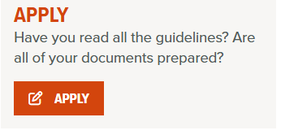Go to [**https://www.4culture.org/grants/launch/**](https://www.4culture.org/grants/launch/) and click the orange “Apply” button on the righthand sidebar. 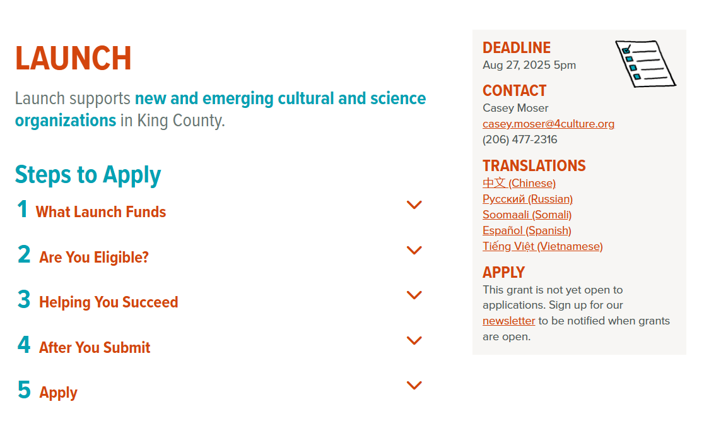  
     
     
   You will be taken to a Microsoft Forms page to submit your information.   
     
   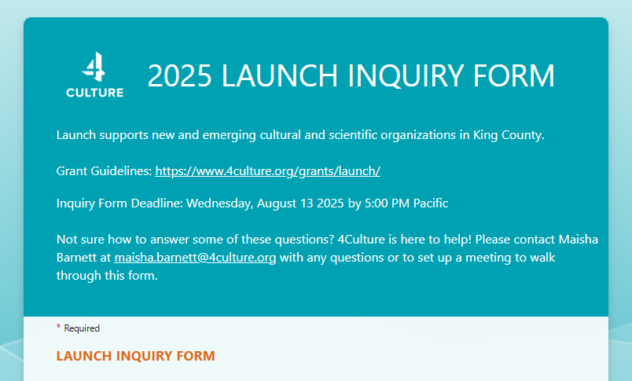
2. Fill out the Inquiry Form online. There are two pages:
   1. The first will ask you for information about your organization. You will also be asked to confirm you’ve created an account on 4Culture’s main grant portal and that you know that you need to also submit additional materials to be considered for Launch.
   2. The second page is optional and will ask you for information to help 4Culture support you and other Launch applicants.

Use the blue “Next” button and the white “Back” button at the bottom of the page to move through the form.  
  
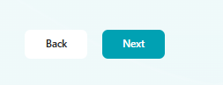  
  
You will need to answer all the required questions in order to submit your form—these will have an asterisk (**\***) next to them.

**Please note you will NOT be able to save a draft of your form**, so you’ll need to be prepared to answer all of the questions in one go. Saving your work in Word or Google Docs will ensure that an internet outage won’t result in lost work and will allow you to work on your form over multiple days. You can use the worksheet included on the following pages to see all of the Inquiry Form questions and help draft your submission. 4Culture is unable to offer extensions if you lose your draft.

1. When you have completed the form, hit the teal “Submit” button at the bottom of the final page to submit your form.  
     
   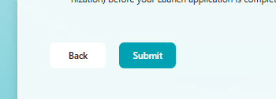  
     
   You will know your Inquiry Form has been successfully submitted when you see the following confirmation screen:  
     
   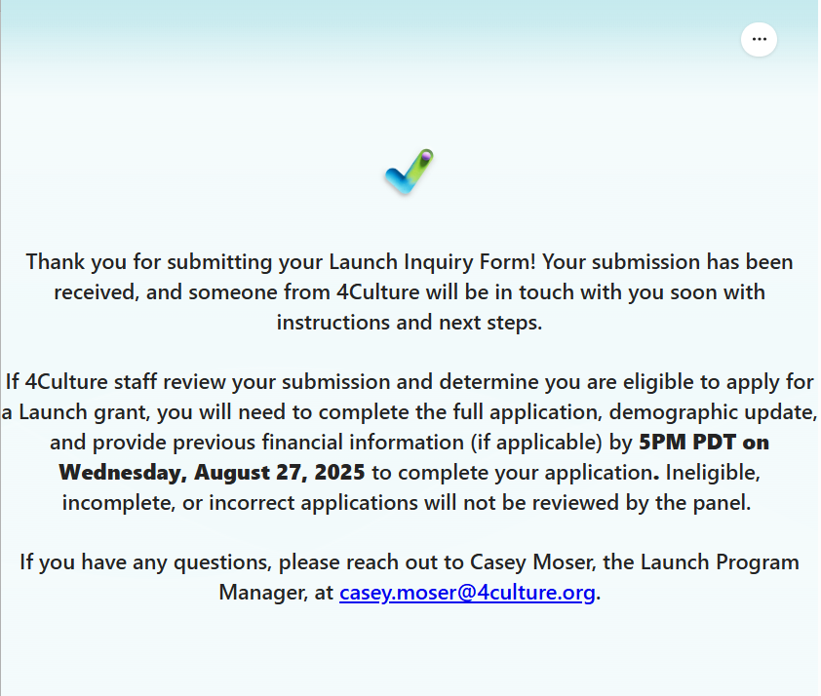

Submitted by accident or need to fix something on your application? Contact casey.moser@4culture.org. If the application deadline hasn't passed yet, she may be able to help.

4Culture staff will review your Inquiry Form to verify your eligibility to apply for Launch funding. If your group is eligible, you will be provided with instructions to complete an online application. Keep an eye out for an email with next steps at the email address you provided in the Inquiry Form.

### Worksheet: Launch Inquiry Form

This worksheet is intended as a tool for applicants to draft their Launch Inquiry Form. We recommend reviewing the eligibility criteria for this grant on 4Culture’s website before starting on this worksheet.

Required questions are noted with an asterisk (**\***). You’ll also find tips from 4Culture staff throughout this worksheet in red text. These tips will not appear in the online application.

Using this worksheet is not required, nor is it an acceptable alternative to the online inquiry form. **ALL Launch Inquiry Forms must be submitted ONLINE no later than Wednesday, August 13th, 2025, at 5pm PDT** by clicking the orange “Apply” button on the righthand side of the Launch grant guidelines page on 4Culture’s website.

**TIP:** Not sure how to answer some of these questions? 4Culture is here to help! Please contact Maisha Barnett at **maisha.barnett@4culture.org** with any questions or to set up a virtual meeting to walk through this form.

**LAUNCH INQUIRY FORM**

This section is **required** and will be reviewed by 4Culture staff to confirm your group is eligible to apply for Launch. The information you include in this form will **NOT** be seen by review panelists or have any bearing on your application aside from verifying eligibility.

**Organization Name \***

What is the name of your group?  
  
**TIP:** The name of your organization should match the name you indicated when you created your account at apply.4culture.org.

**Contact Name \***

What is your name?

**Contact Email \***

What is your email address?

**Discipline \***

Select one (1) discipline that best fits your group. Multi-disciplinary projects should select the discipline that is most prominent for their organization, referring to the definitions in the grant guidelines.

**TIP:** Launch grants are not awarded by discipline. If your organization is multi-disciplinary, select the discipline that is most prominent for your organization. Refer to 4Culture’s discipline definitions on the grant guidelines page for help selecting your primary discipline or reach out to 4Culture with any questions.

* Arts
* Heritage
* Historic Preservation
* Science & Technology

**First Public Program \***

When was your group’s first in-person public program or when will it take place in 2026?

**TIP:** You don’t need to put a specific date, just the month and year are sufficient.

**Programming Description \***

Please provide a brief description of your first public program or a typical public program your group hosts. What was the program or what will it be?Where did it take place or where are you planning to hold it? Who participated or who will you invite? (Suggested Word Count: 100 words or 1-2 sentences)

**Key People** **\***

Please list the names of people involved in your group who hold key board/staff/volunteer positions and in a few words tell us about their involvement (e.g., Jane Smith, Artistic Director; Janelle Scott, Budgeting & Finance Lead; Jaime Saldana, Operations; Jai Sung, Board Member; suggested Word Count: 5-10 words or 2-5 names).

**TIP:** This does not need to be an exhaustive list; 2-5 names are fine.

**Previous 4Culture Grants \***Has your organization ever received a Sustained Support grant from 4Culture?

* Yes
* No
* Not yet, but we plan to apply this year

**Program Track \***

Which track of the Launch program best fits your organization?

**TIP:** If your group meets the criteria for both tracks, we recommend selecting “Emerging Organization” and contact 4Culture to get the applicant guide for Emerging Organizations.

* **New Organization**: Organizations that began programming and operations within the last three years (or plan to begin programming in 2026) and have never received a Sustained Support or Launch grant from 4Culture. This can include new collaborative ventures run by existing organizations that offer new and distinct programs or services and have a decision-making body and structure that is independent of the participating organizations.
* **Emerging Organization:** Organizations that are hiring their first full-time equivalent (FTE) staff member working 20+ hours per week and do not yet have 501(c)(3) status or have had 501(c)(3) status for less than three years.

**Public Benefit(s) \***

Please select one or more Equity or Geographic Inclusion Public Benefit(s) your organization has provided or plans to provide in King County. Please note that the word “cultural” in the options below includes science and technology organizations.

**TIP:** You can select as many as you wish, but this information will not be reviewed by the peer panel.

* Providing free or low-cost attendance to cultural organizations and cultural facilities for county residents who have economic, geographic, and/or other barriers to access.
* Providing free access to curriculum-related arts, science, and heritage programs for public school students with an emphasis on underserved students.
* Increasing the diversity of staff and governing boards of cultural organizations.
* Increasing opportunities for access to cultural facilities, programs, and services for diverse and underserved communities.
* Providing programming that appeals to diverse populations within the county.
* Planning and implementing cultural programs or collaborating with other cultural organizations to extend the reach and impact of cultural programs to diverse and underserved populations and communities.
* Planning and implementing cultural programs and activities outside of Seattle.
* Partnering with other cultural organizations on cultural programs and activities outside Seattle, through direct investment or in-kind support, on priority projects and initiatives.
* Providing cultural programming to communities outside the city in your organization is primarily located, either directly or in partnership with other entities.

**State Incorporation \***

Which of the following statements best represents your group’s Washington State incorporation status?

If you're not sure of your group's state incorporation status, you can try searching for your group through the Washington Corporations and Charities Filing System. [**Follow steps 1 through 4 of this guide to search for your organization**](https://www.4culture.org/wp-content/uploads/2025/05/How-To-Find-your-Washington-Articles-of-Incorporation_a11y.pdf). If your organization does not appear, you are likely not yet incorporated.

* Our group is incorporated in Washington, and we have a UBI number
* Our group has submitted our Articles of Incorporation to the state, but we do not have a UBI number yet
* Our group is currently incorporated with the state and has a UBI number, but we are changing our business formation
* Our group has not yet incorporated with Washington State.
* None of the above

**TIP:** Not sure what a UBI number is? Check out our[**Glossary of 4Culture and Nonprofit Jargon**](https://bit.ly/4candnonprofitjargon)or reach out to 4Culture for more information.

**Federal Recognition \***

Which of the following statements best represents your group’s federal 501(c)(3) status?

If you're not sure of your group's federal 501(c)(3) status, you can try searching for your group through the IRS's website. [**Follow steps 1 through 4 of this guide to search for your organization**](https://www.4culture.org/wp-content/uploads/2025/05/How-To-Find-your-Federal-IRS-Determination-Letter_a11y.pdf). If your organization does not appear, you are likely not yet its own 501(c)(3).

* Our group has 501(c)(3) status and we have a letter of determination from the IRS
* Our group has filed for 501(c)(3) status, but we have not received a response to our application yet.
* Our group is contracted with a fiscal sponsor, and we are working under the umbrella of their 501(c)(3) status
* Our group is actively looking for a fiscal sponsor or has applied for fiscal sponsorship, but we have not signed a contract yet
* We have not applied for 501(c)(3) status, and we do not have a fiscal sponsor
* None of the above

**TIP:** Not sure what a fiscal sponsor or letter of determination is? Check out this our [**guide for Launch applicants applying with fiscal sponsors**](https://bit.ly/4claunchfiscalsponsorship) or our [**[Glossary of 4Culture and Nonprofit Jargon](https://bit.ly/4candnonprofitjargon)**](https://bit.ly/4candnonprofitjargon) or reach out to 4Culture for more information.

**Fiscal Sponsor\***

If you indicated that you are currently contracted with a fiscal sponsor above, let us know who your fiscal sponsor is.

**TIP:** If you do not have a fiscal sponsor, you will not see this question and it is not required for your group. If you are fiscally sponsored, just include your fiscal sponsor’s name. We strongly recommend all fiscally sponsored applicants read our [**guide for Launch applicants applying with fiscal sponsors**.](https://bit.ly/4claunchfiscalsponsorship)

**4Culture Account \***

You also need to create an account for your group at [**https://apply.4culture.org**](https://apply.4culture.org/) before you submit this form.

Review your account and profiles by going to [**https://apply.4culture.org/your-profiles**](https://apply.4culture.org/your-profiles)to confirm all the information is correct. Inaccurate or incomplete information may make your application ineligible.    
  
**TIP:** Required profile information for Launch applicants:

* Mission: a brief description of an organization's purpose, who it serves, and how it serves them.
* Federal EIN: a unique number that identifies the organization to the Internal Revenue Service (If you don’t have one, write “n/a”; if you have a fiscal sponsor, include their EIN).
* WA State UBI: a number used by Washington State to distinctly identify organizations (This should be specific to your group. If you don’t have one, write “n/a”; do not put in your fiscal sponsor’s UBI).
* Date incorporated: The date of formation logged when you incorporated with the state (If you have not yet formally incorporated, write “n/a”).
* King County Percentage: How much of your programming has taken place or will take place in King County?
* By checking this box, you are confirming that you have created an account on apply.4culture.org and the information in your personal and account profiles is correct and complete.

**Next Steps \***

If 4Culture staff review your submission and determine you are eligible to apply for a Launch grant, you will need to complete the full application, demographic update, and provide previous financial information (if applicable) by **5PM PDT on Wednesday, August 27, 2025,** to complete your application. Ineligible or incomplete applications will not be reviewed by the peer review panel.

* By checking this box, you are confirming that you understand you also need to complete the full application, submit a demographic update for your organization, and provide previous year financial information (if applicable for your organization) before your Launch application is complete.

**OPTIONAL QUESTIONS**

This section is optional and will not be used to evaluate your group’s eligibility for a Launch grant. The information you include in this section will not be seen by review panelists or have any bearing on your application aside from verifying eligibility.

**Outreach Efforts**

How did you hear about the Launch program? Your response will be used to help 4Culture know how to best reach future Launch applicants.

* Web Search
* 4Culture eNews
* From 4Culture Staff
* 4Culture Event (Hello 4Culture, Doors Open Share Outs, Launch Outreach Events, etc.)
* Social Media
* From a Friend or Colleague
* Other

**Other**

If you selected "Other," please explain.

**Experience**

How much experience do you or someone else in your group have with the following topics? 4Culture staff may use any information you provide here to direct you to application supports that are available to Launch applicants.

**TIP:** This section is optional and will not be used to evaluate your group’s eligibility for a Launch grant or be seen by the peer review panel scoring your submission. We hope you feel comfortable being candid with us so that we can do our best to support your group.

Writing Grant Applications

* None
* Some
* A Lot

Nonprofit Budgeting

* None
* Some
* A Lot

Project Planning and/or Organizational Development

* None
* Some
* A Lot

Recruiting, Labor Law Compliance and Taxes, Compensation Strategy, and Other Human Resource Topics

* None
* Some
* A Lot

Purchasing, Securing a Long-Term Lease for, and/or Making Renovations to a Facility

* None
* Some
* A Lot

**Additional Support**

Will your group need any additional support to complete your application? E.g., translation assistance, disability accommodations, etc. 4Culture staff may use any information you provide here to direct you to resources that make our grants more accessible.

**TIP:** This section is optional and will not be used to evaluate your group’s eligibility for a Launch grant or be seen by the peer review panel scoring your submission. We hope you feel comfortable being candid with us so that we can do our best to support your group. If you select “Yes” or “Not Sure” to the last question, someone from our staff will be in touch to see how we can assist you.

* Yes
* No
* Not Sure

## Step 3: Completing the Full Application for New Organizations

Once your eligibility to apply for Launch has been verified, 4Culture staff will let you know via email. In this message there will be a link to access the application. You can use the following instructions to start and save a draft of your application.

1. Click on the link provided to you in the email from 4Culture.  
     
   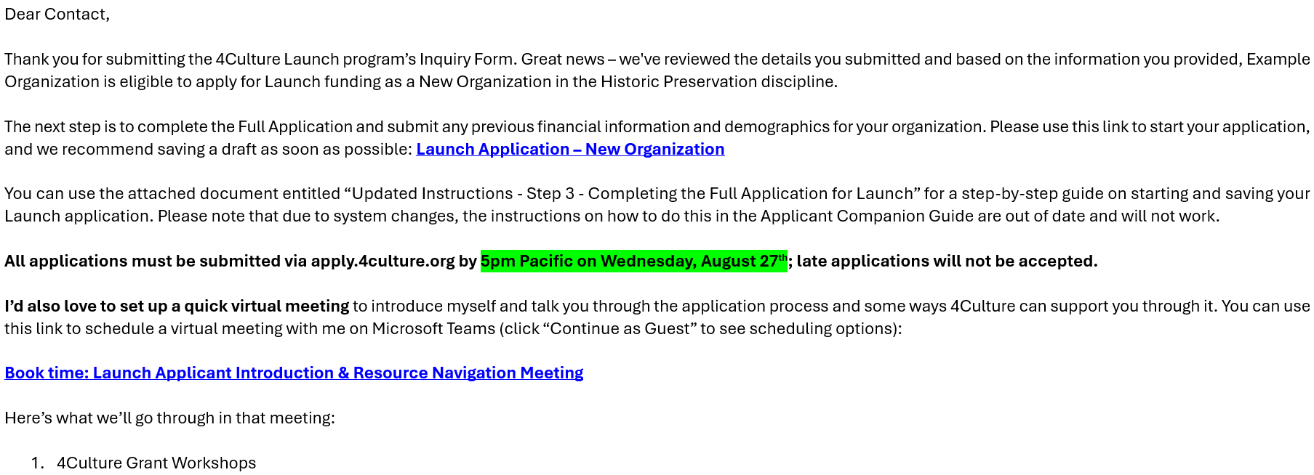
2. If prompted, log in using the username and password for your 4Culture account (hint: the username is likely your email address).   
     
   If you forgot your username and/or password, use the links underneath the Sign In button to get your username or a password reset link sent to you.  
     
   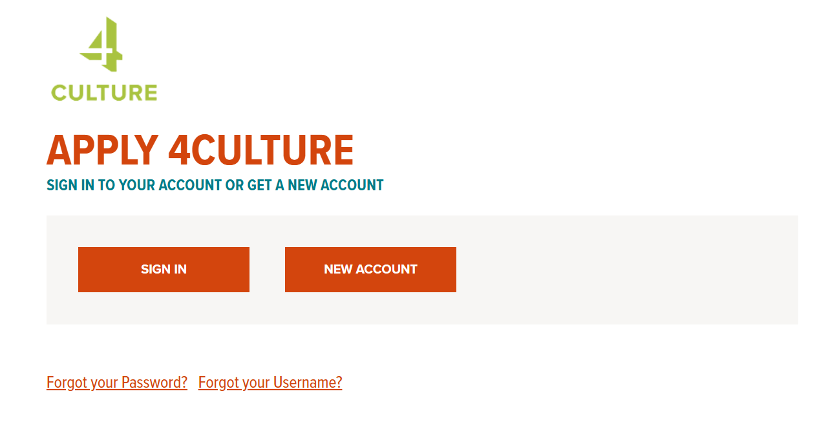
3. This should open the application form, and you are ready to start entering your responses.  
     
   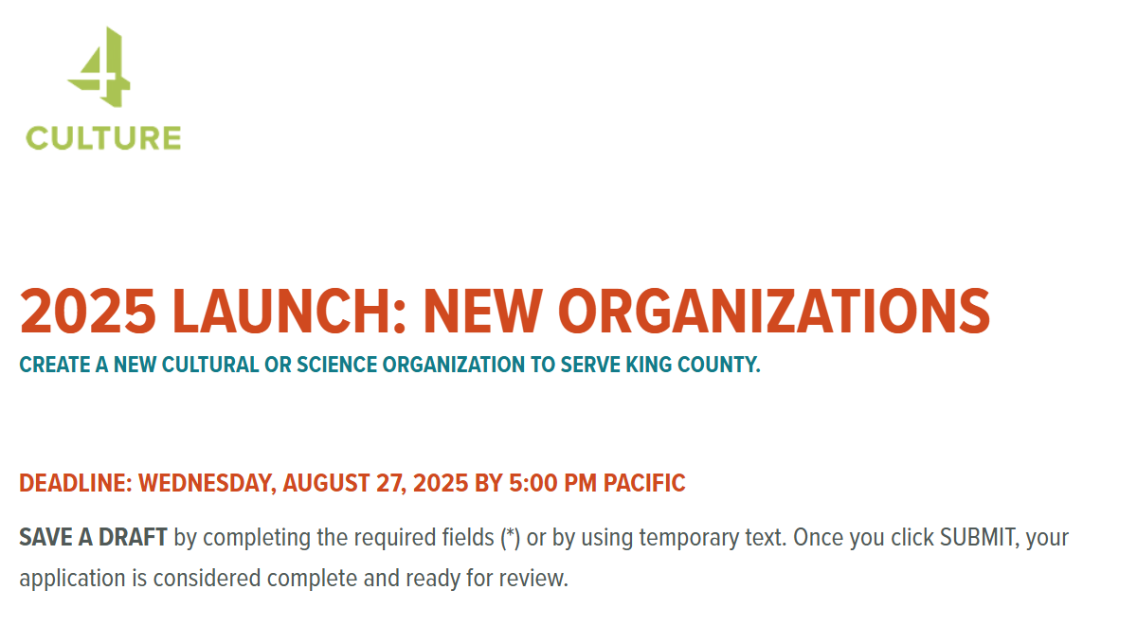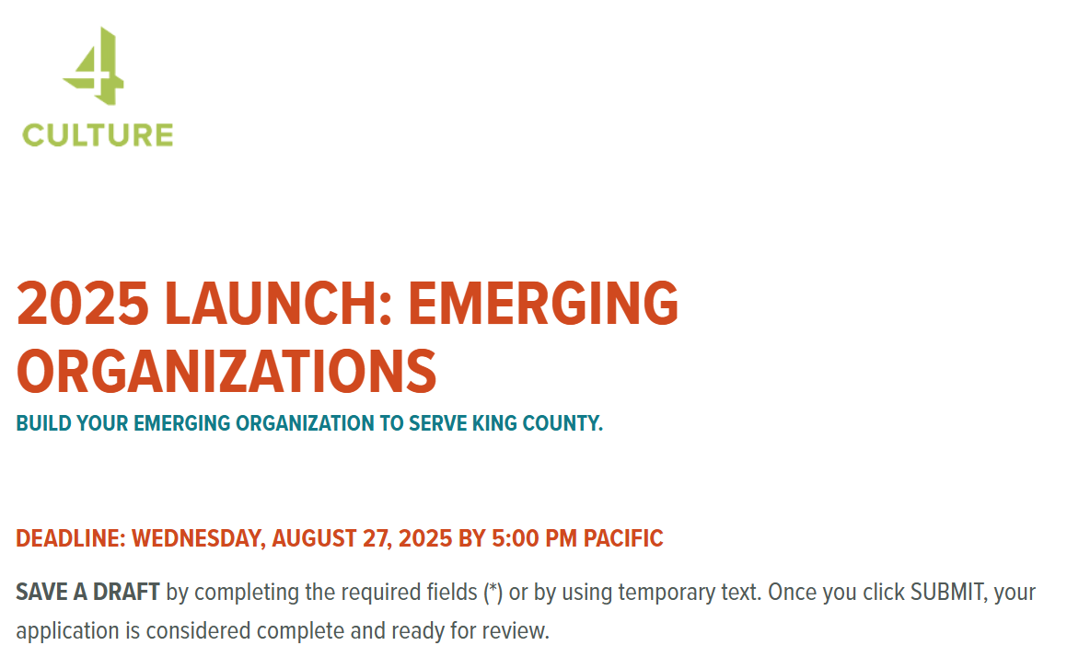
4. If you're not ready to complete the application yet, you can save the open application as a draft to return later. Hit “Save a Draft” at the bottom of the page if you want to keep working on your application at a later date.   
   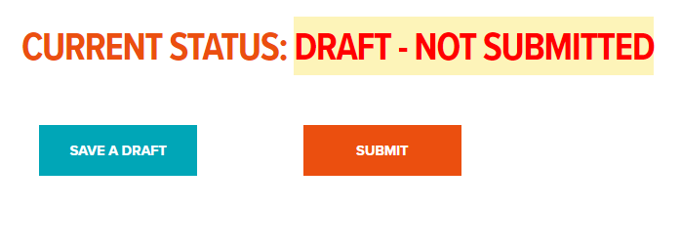  
   Do not close the window until you see a message confirming your draft has been saved.

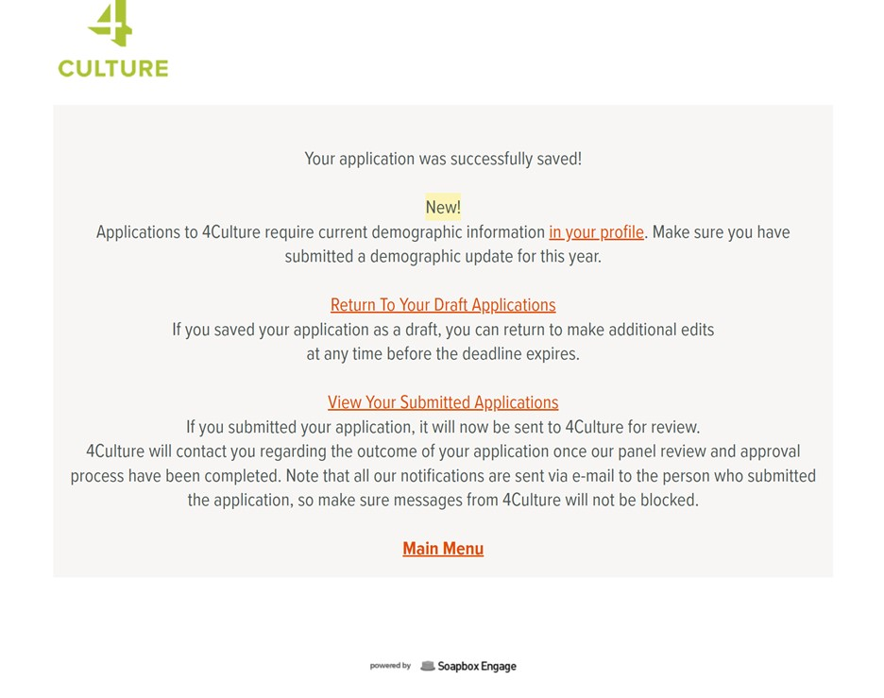

Please note that you will need put placeholder text in or make a selection in all required fields to save a draft. If you are getting an error message whwn you try to submit, thre are troubleshooting tips later in this document.

4Culture also recommends periodically saving your draft as you are working on your application. The grant portal will automatically log you out of the browser after 60 minutes of inactivity. The system does not recognize typing as activity, only saving a draft. Click "Save a Draft" at the bottom of the page every 50 minutes or so to prevent data loss.

Saving your work in Word or Google Docs will ensure that an internet outage won’t result in lost work. 4Culture is unable to offer extensions if you lose your draft. You can also keep track of your word count and spelling this way. The Full Application questions are provided in the next section of this document to make this easier for you.

1. To access your saved application later, go to [**apply.4culture.org**](https://apply.4culture.org/) and log in using the username and password for your 4Culture account.
2. At the top of the page, click “Start or continue an application.”  
     
   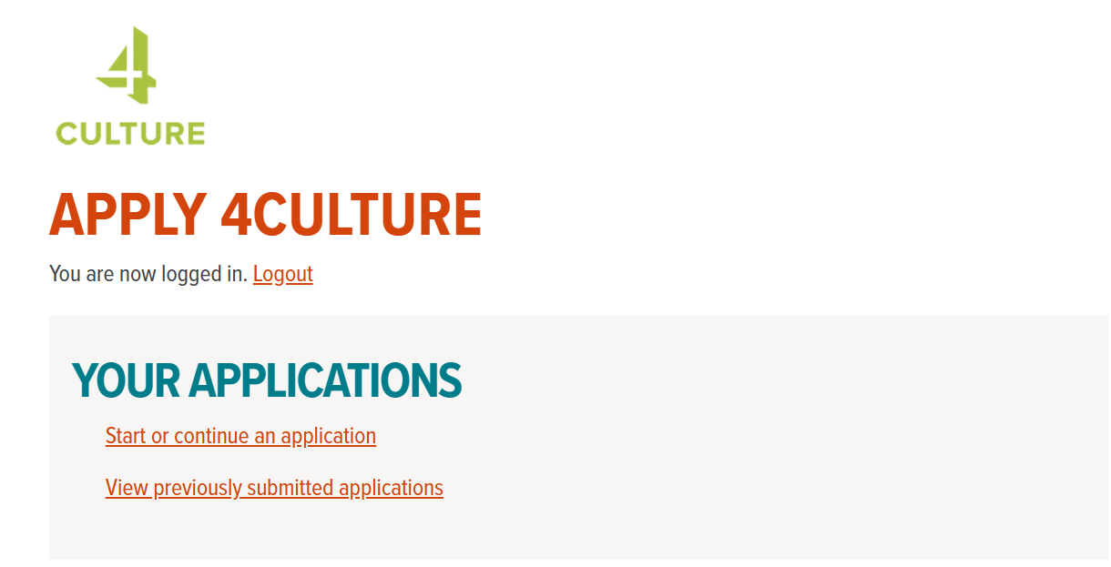
3. At the top of the page under where it says “Your Applications,” there will be a link to access the Launch Full Application. Click "View/Edit" to open the application.  
     
   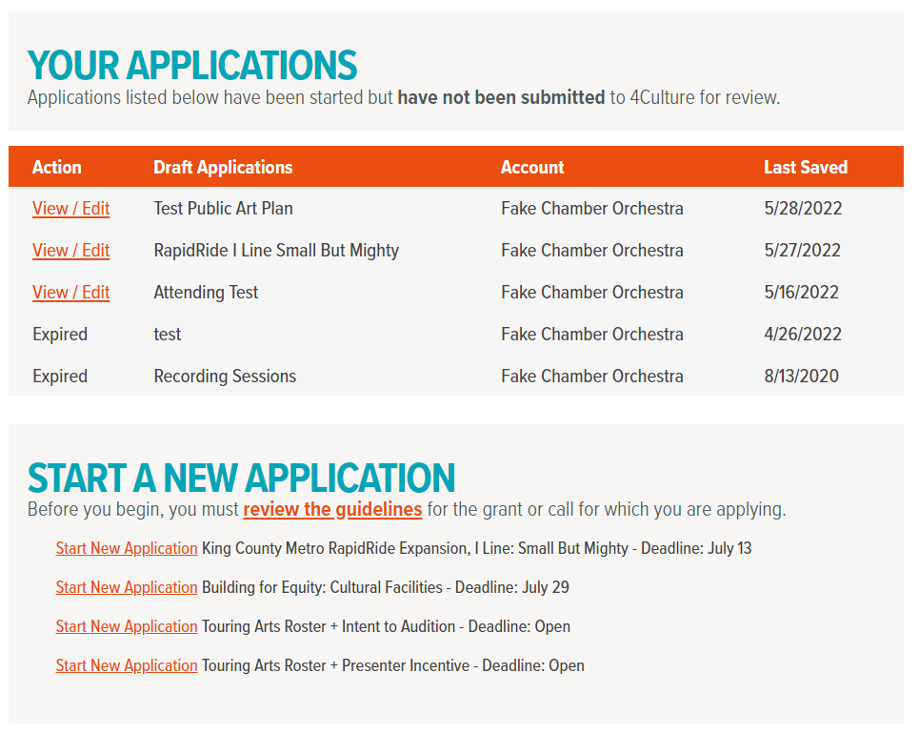

Launch Application

1. Fill out the Full Application online. Double-check that you have answered all the required questions—these will have an asterisk (**\***) next to them. Remember to save often!
2. Hit “Submit” when you’re done and ready to send your application to 4Culture (make sure to do this before the grant deadline).



You will receive a confirmation email to the email address associated with your 4Culture account if your submission was successful.   
  
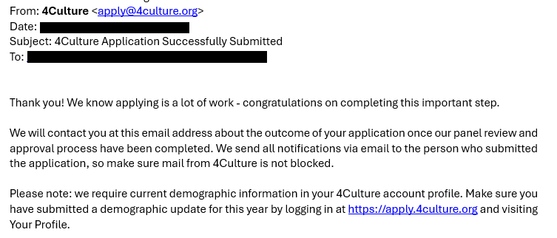  
  
If you still have the option to View/Edit your application, you have not yet submitted the form. If it shows up as “Pending”, your application has been submitted to 4Culture.

Getting an error when you try to save or submit? Here are some suggestions to troubleshoot the issue:

* An error message will appear at the top of your application. Review this message to learn more about the issue.
* Make sure you have filled out all of the required fields. Fields marked with an asterisk (**\***)are required, you will need to put information or placeholder text in these fields in order to save a draft.
* Do your narrative responses contain special characters? The text fields in the application can only accept plain text.
* Are your attachments in one of our accepted file formats? Valid file types are Word (.doc, .docx), Excel (.xls, .xlsx), PDF (.pdf) and JPEG (.jpg).
* Are your attachments too big? Each attachment must be smaller than 2 MB.

**Don’t close the application until you're able to address these errors and save your progress or submit your application.**

Submitted by accident or need to fix something on your application? Contact casesy.moser@4culture.org. If the application deadline hasn't passed yet, she may be able to revert your application to a draft.

Don’t forget to submit your organization’s demographic and financial information, which are also due **August 27, 2025, by 5pm PDT**.

### Worksheet: Launch Full Application

This worksheet is intended as a tool for applicants to draft their application. We recommend reviewing the evaluation criteria for this grant on 4Culture’s website while you’re working on your application.

Required questions are noted with a red asterisk (**\***). You’ll also find tips from 4Culture staff throughout this worksheet in red text. These tips will not appear in the online application.

Using this worksheet is not required, nor is it an acceptable alternative to the online application form. **ALL Launch Applications must be submitted ONLINE at** [**www.apply.4culture.org**](http://www.apply.4culture.org) **no later than Wednesday, August 27th, 2025, at 5pm Pacific Time.**

**APPLICATION**

**Discipline \***

**TIP:** The discipline will be pre-filled for you based on what you submitted in your Inquiry Form. If the discipline looks incorrect to you, please contact the Launch Program Manager before changing it.

* Arts
* Heritage
* Historic Preservation
* Science & Technology

**Organization Description \***

Please provide an introduction and overview of your group. What made you want to start a new organization? What is your vision for the organization? (Suggested word count: 250 words)

**TIP:** Think of this as the elevator pitch for your organization. Remember that some review panelists might not be familiar with your organization and try to avoid industry jargon. How would you describe your organization to someone you met on the street? Share why you’re passionate about it and why this work is important to you. This response will provide context for the rest of your application.

**Programming \***

Please describe a sampling of programs, services, and/or events your group is planning or has produced in the last few years that represent your organization's work. How were the ideas for those programs, services, and/or events developed? Where did/will they take place? Please provide dates and locations for past or upcoming programs, services, and/or events when known. (Suggested word count: 250 words)

**TIP:** This section is helpful for review panelists to understand how the passion and vision you described in the previous questions gets turned into public programming. They will be looking here for insight into how your group operates (part of the Goals and Feasibility criterion), as well as more information about the benefit you’re offering to King County residents and visitors (part of the Public Benefit criterion).

**Community \***

Please describe the community(ies) you are operating in or plan to operate in. Who are you planning to reach with your work? What will your organization add to your community(ies) that has not existed before? How is your programming distinct from what already exists? (Suggested word count: 250 words)

**TIP:** This section is helpful for review panelists to understand what new programming or services you are offering. Tell us about what exists and how your organization adds something new to your field and/or community (part of the Quality and Innovation criterion).

**General Public Benefits \***

4Culture defines Public Benefit as the opportunity for King County residents and visitors to access and engage in arts, science, and other cultural activities, events, communities of practice, historic and cultural spaces, and works of public art related to our program areas. It is also a service requirement for all recipients of funding from 4Culture. Learn more about public benefit and how it shapes 4Culture’s work here:[**https://www.4culture.org/public-benefit/**](https://www.4culture.org/public-benefit/)

Please select any efforts your group will undertake in the coming years to make your work more accessible to King County residents, particularly for underserved populations.

**TIP:** Check as many as your group can reasonably complete in a given year. Peer review panelists will be using this section to award points for the Public Benefit criterion.

* Providing access to rehearsal, performance, and other spaces through open hours
* Producing programs, performances, experiences, and providing access to public collections
* Education programs in and out of school
* Programming and facilities upgrades to support individuals with disabilities
* Preservation and transmission of traditional cultures and crafts
* Cultural content production (events, programs, didactics, education materials, etc.)
* Career building opportunities such as internships, apprenticeships
* Multidisciplinary partnerships and resources sharing
* Improving outreach and communications to diverse and underserved audiences
* Field services: career development, professional networks, technical assistance, skill-building, research & advocacy
* Other

**Other Public Benefit(s)**

If you selected “Other” from the list of public benefits above, please describe any other efforts your group will undertake to make your work more accessible to King County residents, particularly for underserved populations. (Suggested word count: 100 words)

**TIP:** We strongly recommend describing the other public benefit you plan to offer if you checked the “other” option in the previous question. Peer review panelists will be using this section to award points for the Public Benefit criterion.

**Relevant Expertise / Experience / Accomplishments \***

Who will be involved in managing your group (staff, volunteers, consultants, contractors, etc.)? What role(s) will they play? Describe the experience and skills your team possesses to complete the work successfully (resumes are not required - brief summaries are preferred). Describe how your team works together and makes decisions. (Suggested word count: 250 words)

**TIP:** This section is where you can demonstrate to the peer review panel that you have a capable team working with your group. If you don’t have everyone in place just yet, describe who you are looking to add to the team and what knowledge they will bring to the table. Your response will be used to award points for the Goals and Feasibility Criterion.

**Planning & Goals \***

Tell us about your plans to get your group’s operations up and running (planning, raising money, bringing in volunteers and staff, setting up operating structure, developing programs and services, etc.) What are the top 2-3 goals of your organization for 2026-28? Why are these goals a priority for your group, and how will you measure your progress towards those goals? (Suggested word count: 250 words)

**TIP:** You don’t need to have overly high-reaching goals; in fact, it’s better to show that your goals are reasonable and in line with your group’s current capacity and phase of organizational development. Your response will be used to award points for the Goals and Feasibility Criterion.

**Budget \***

How much are you requesting from 4Culture? New Organizations can request:  
  
$45,000 ($15,000 per year in 2026 - 2028)  
$90,000 ($30,000 per year in 2026 - 2028)

$180,000 ($60,000 per year in 2026 - 2028; only available to organizations outside the City of Seattle)

* $45,000
* $90,000
* $180,000

**Income\***

Do you have other projected sources of income over the next three years (2026-2028)? Your best estimate is fine, and 4Culture will not hold you to these numbers if things change. Please include your Launch grant request in your calculations under "4Culture Launch Request". Please provide answers in United States Dollars ($).

**TIP:** Your preliminary budget figures will be used to contextualize the information about your programming and goals that you provide in the application.

4Culture Launch Request*

Applicant Cash on Hand

Individual Donors

Foundations

Government

Corporations

Earned

In-Kind

Other

**TIP:** The income total will calculate automatically based on what you put in the fields above.

**Expenses \***

Tell us about your group's expenses for the next three years (2026-2028). What costs will your group incur to successfully start your work and achieve your preliminary goals? Your best estimate is fine, and 4Culture will not hold you to these numbers if things change.

Please provide answers in United States Dollars ($). Ensure your total income is greater than or equal your total expenses (in other words, the budget must demonstrate your group's plans are financially feasible).

People

Services

Supplies

Promotion

Fundraising

Transportation/Shipping

Planning

Equipment/Fixtures

Documentation/Assessment

In-Kind

Other

**TIP:** The expense total will calculate automatically based on what you put in the fields above.

**Budget Notes**

Provide details of any items that require further information for the review panel to understand project finances, e.g., if any of the income or expenses listed above have already been confirmed, what is included in “other” expenses and income; sources of grants; rationale for totals, etc. (Suggested word count: 250 words)

**TIP:** This response is optional but highly recommended for review panelists to better understand your plans.

**Advancing Equity \***

Does your project specifically benefit communities of color and/or historically marginalized communities in King County? If so, how and why? Does the project collaborate with members of these communities, and if so, how?

This is not required for funding, but it will be a criterion that peer review panelists will consider when evaluating your application. (Suggested word count: 250 words)

**TIP:** If your project has a direct, meaningful connection with and aims to serve historically marginalized people and communities, then use this space to talk about that. How will your project ensure that the impact of this connection is meaningful and ongoing? Be specific about the communities you are discussing. This section will be used to award points for the Advancing Equity criterion.

**Economic Impact \***

What economic impacts will your group have in King County? This can include wages, contractors, volunteers and employment; tourism impact; provision of affordable space or reduced cost-services and offerings; community well-being and quality of life; direct spending on goods and services; visitor spending at other local businesses; or other impacts. (Suggested word count: 250 words)

**TIP:** Economic Impact can be measured in many ways – please share any data and narratives that your organization has collected. This may include:

* Job creation and support
* Generating government revenue through taxes
* Tourism promotion and local business spending
* Purchasing goods and services from local businesses
* Quantifying volunteer hours through a standard rate to determine a total monetary value
* Highlighting public benefits that your organization provides that would have otherwise required government funding
* Estimating the value of programs provided for free that would have otherwise been paid for by individuals
* Other ways in which your organization positively impacts the local economy

4Culture also recognizes the long-term economic benefits of improved education, strong community ties, and community development.

This section will be used to award points for the Economic Impact criterion. Particularly strong answers to this question typically:

* Quantify impact when possible/applicable
* Explicitly connect their organization to local economic development priorities
* Demonstrate that they did research on this topic, citing sources and giving national statistics

**REQUIRED SUPPORT MATERIALS**

Your application will not be complete without the following:

**DEMOGRAPHIC INFORMATION \***

Applicants must provide demographic information for their organization. This information will not be part of your application and will not be seen by the peer review panel. We gather demographic information to better evaluate the success of our efforts to reach all communities in King County. Make sure you have provided demographic information for the current year before submitting your application.

Submit your demographic information here using the instructions found later in this document: [**http://apply.4culture.org/your-profiles**](http://apply.4culture.org/your-profiles)

**FINANCIAL INFORMATION \***

Applicants who were operating prior to 2025 must provide previous year financial information for their organization.

Submit your financial information here using the instructions found later in this document: [**http://apply.4culture.org/your-profiles**](http://apply.4culture.org/your-profiles)

**OPTIONAL SUPPORT MATERIALS**

You do not need to include this information, but you can if you would like to.

**OPTIONAL ATTACHMENT**

Applicants may upload one document of no more than five pages that helps to tell the story of your group and its history and/or goals for the review panel. This is not required.

**TIP:** The peer review panel will review ONE optional additional supporting document. Additional attachments beyond that may be removed from your application.

Examples of things that could be uploaded as an optional attachment:

* Flyers and marketing materials for upcoming programming
* A program, playbill, event schedule, or run of show from a past or planned event
* Photos of a past event or program, planning session, or a planned venue
* A selection from your organization’s bylaws, strategic plan, or governing documents
* Letters of support from other organizations or community figures
* Anything else you think helps support your candidacy for a Launch grant

Peer review panelists are encouraged to but not required to review an applicant’s optional attachment, so please make sure the most important information is included in this application form and not in the attachment. You are encouraged to reference the attachment in the application form.

**Attachments must be less than 2MB**. Valid document file types are Word (.doc, .docx), Excel (.xls, .xlsx), PDF (.pdf), and image (.jpg) files.

**TIP:** If your file is too large, use an online file compression tool like [**www.youcompress.com**](http://www.youcompress.com)to reduce the size.

## Step 4: Completing Your 2025 Demographic Information

Each year, 4Culture requires applicants and grantees to submit updated demographic information for your organization. Information about our applicants is used by 4Culture to help us understand who we serve and how we can increase program access for all King County residents and communities. **Your specific answers cannot be seen by program managers or peer review panels and will not affect funding.**

We welcome any questions or comments about 4Culture's demographic data collection or efforts to increase program access for all communities. Please contact the program manager for the grant application or artist call for which you are applying.

1. Go to [**apply.4culture.org**](http://www.apply.4culture.org/)**.**
2. Once you’re logged in, click **Update your Account and Personal Profile.**

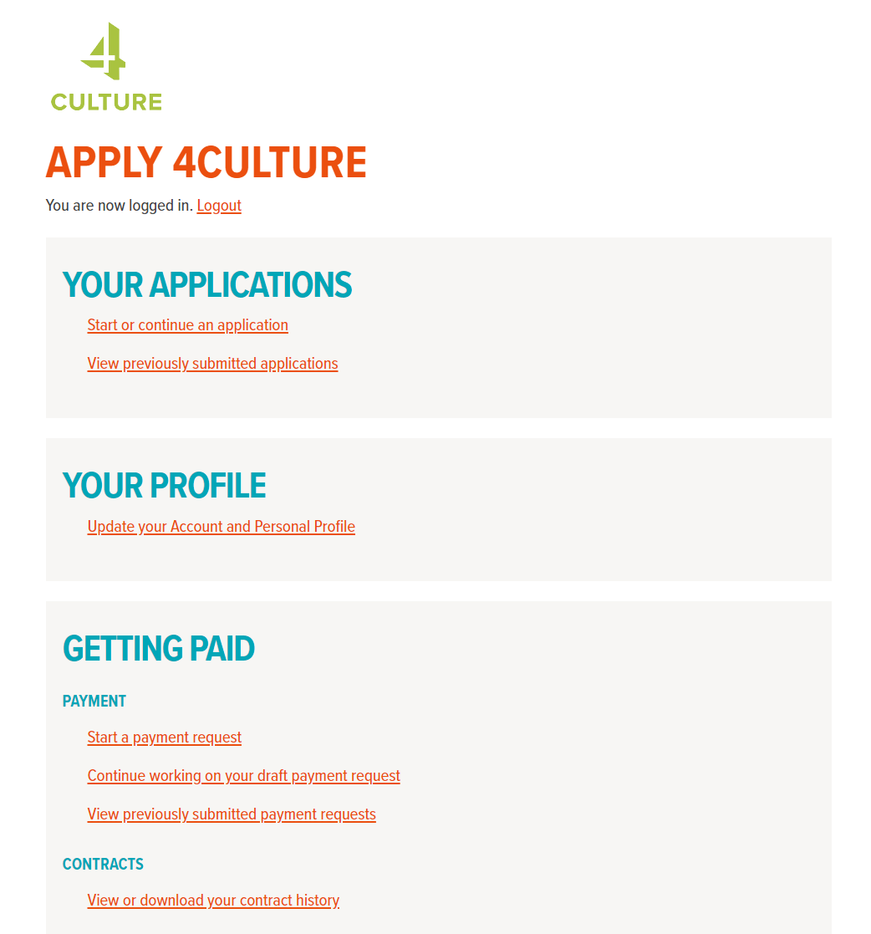

1. Under "Demographic Updates", click "**View / Edit your annual demographic updates".  
     
   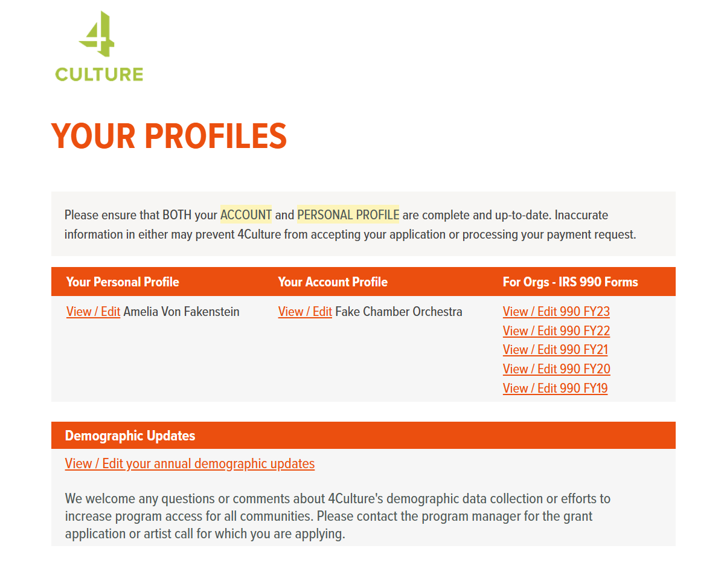**
2. Click **"Start a new organization applicant update".  
     
   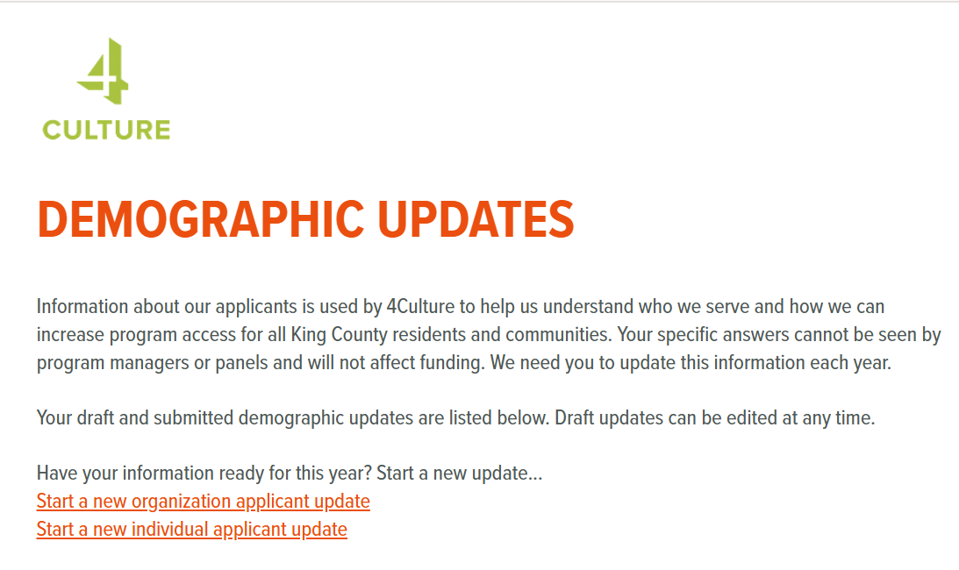**
3. **Fill out the demographic information** requested to the best of your knowledge. If you don't know the answer to a question, you can use the "Declined/No Response" option.   
     
   Please note that even if you think you know how members of your staff and board identify, it is a demographic data best practice to ask for them to provide this information in an anonymous survey instead of reporting on their demographics without their input.   
     
   **4Culture has put together a**[**sample survey**](https://apply.4culture.org/storage/documents/sample-demographic-survey.pdf)**(and**[**survey instructions**](https://apply.4culture.org/storage/documents/demographic-survey-introduction.pdf)**) that you can use to gather demographic information from your board and staff.** You do not have to use this survey to collect demographic data if your organization prefers to do this another way. **Do not send individual surveys to 4Culture.**
4. You can save your work on the demographic update and come back to it later by using the teal "Save a Draft" button at the bottom of the form.

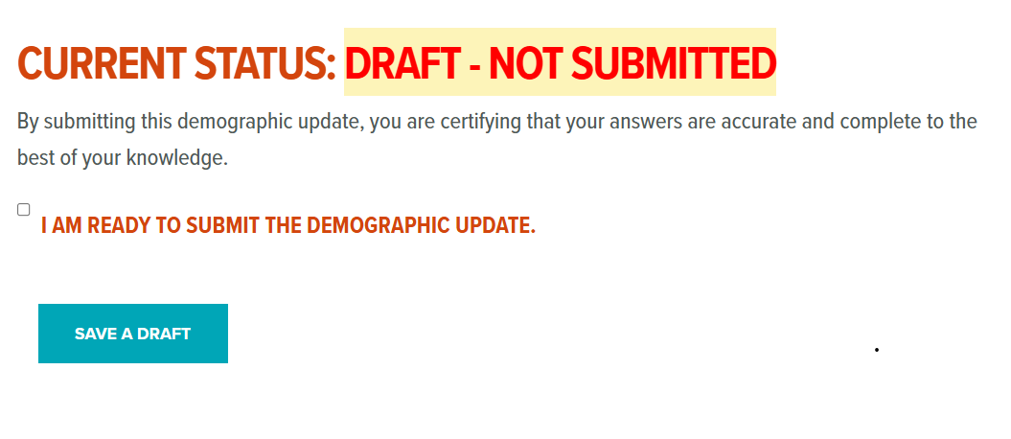

To access your saved form, repeat steps 1-3 and then, instead of starting a new update, clicking "View/Edit" next to your saved demographic form.  
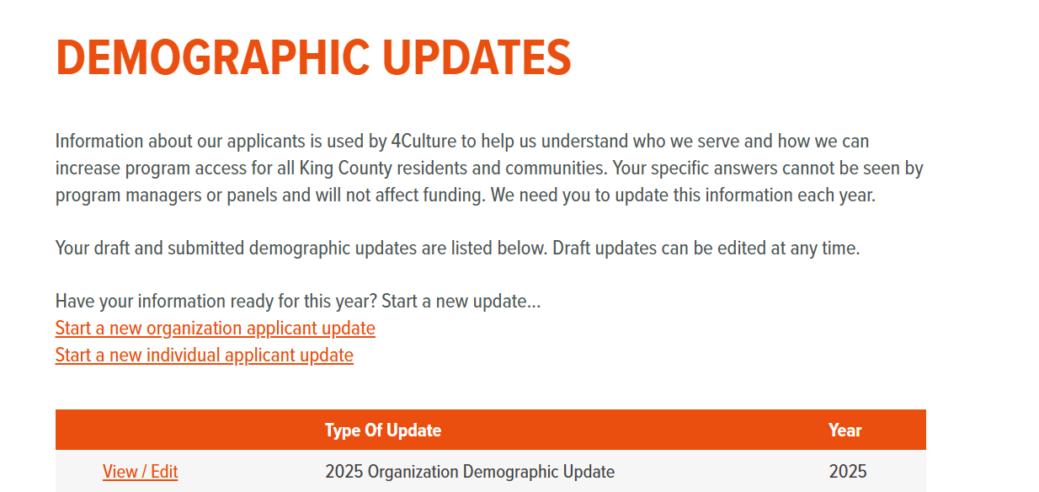

1. When you are ready to submit your organization's demographic form, check the box at the bottom of the form above the teal button where it says "I am ready to submit the demographic update".   
     
   

The teal "Save a Draft" button will turn into an orange "Submit" button. Click the "Submit" button to complete your demographic update.

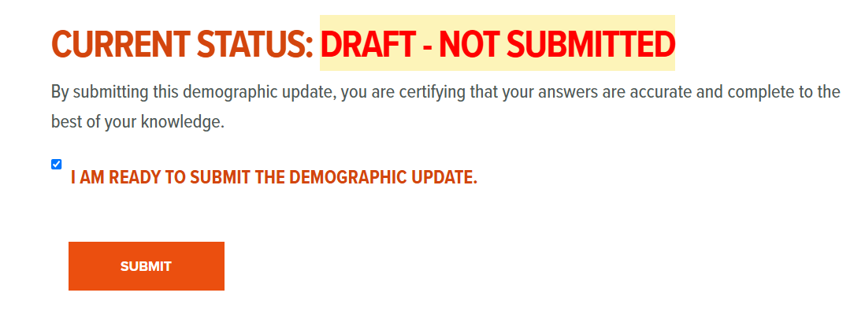

You can tell your demographic update was submitted successfully if you repeat steps 1-3 and instead of seeing "View/Edit" next to your update, you instead see "Submitted - View".

## Step 5: Filling Out Your Previous Year Financial Information

Note: This step is only required for organizations who were in operation prior to 2025. **If your group does not have financial information for those years, please skip this step.**

1. Go to [**apply.4culture.org**](http://www.apply.4culture.org/)**.**
2. Once you’re logged in, click “Update your Account and Personal Profile”.
3. On the righthand side of the page under the orange banner that says, “For Orgs – IRS 990 Forms”, click “View / Edit 990 FY24”  
   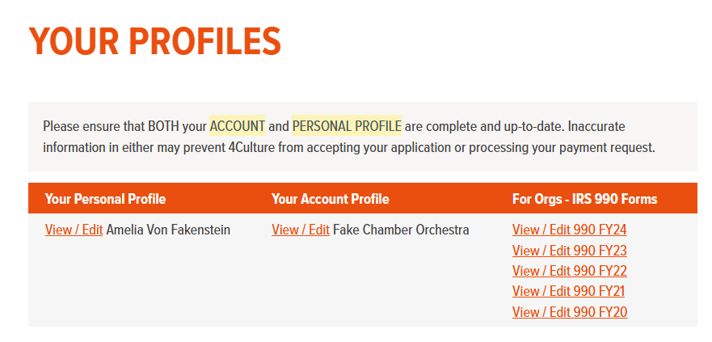
4. Skip the instructions that are included at the top of the form and scroll down to the form itself.  
     
   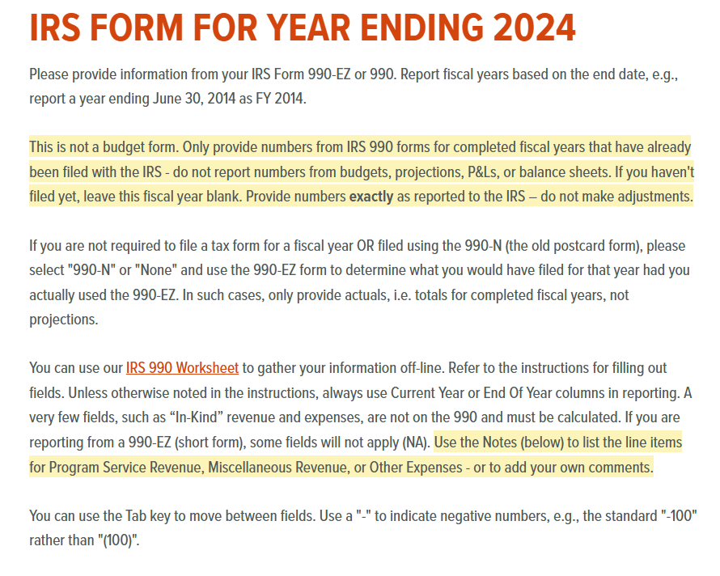
5. If your group is a 501(c)(3) that has filed a 990, 990-EZ, or 990-N, select the appropriate form from the first dropdown menu. If you have never filed a 990 or have your previous year financials in another form, select “None”.  
     
   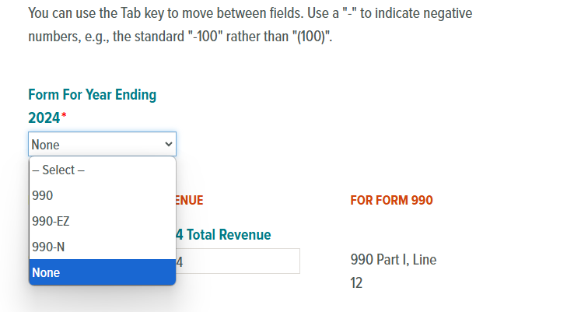
6. You only need to fill out 2 fields: **Total Revenue** and **Total Expenses**. If your group is a 501(c)(3) that has filed a 990, 990-EZ, or 990-N, you can use the line numbers to find that information on your previous filing.   
     
   If you have never filed a 990 or have your previous year financials in another form, you can enter your total revenue and total expenses from whatever financial report you used.  
   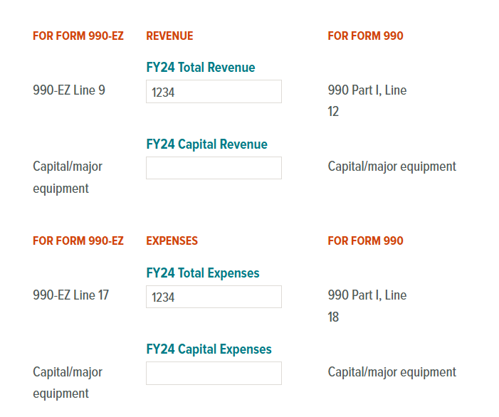
7. Scroll down to the bottom of the page and hit the orange “Submit” button.  
   
8. Repeat if applicable for fiscal year 2023.

# **What to Expect After You Submit Your Application**

Congratulations! We know how much work it takes to get to this point, and we are looking forward to reading what you’ve submitted. Here’s what happens next:

## Initial Review

The first thing that happens once you submit your application is that 4Culture reviews it to make sure it is complete and in line with program guidelines. If anything is missing or needs resolution, the Launch Program Manager will reach out to you with further instructions. Make sure you also remember to submit your demographic information and financial details – your application is not complete without these pieces.

## Peer Review Panel & Funding Decisions

Once we’ve confirmed your application is complete, 4Culture facilitates panels of peer reviewers to evaluate all the completed, eligible applications. Peer reviewers are cultural or scientific practitioners, administrators, and subject-matter experts with ties to the King County community. Reviewers change from cycle to cycle. 4Culture staff do not score applications or try to influence the outcome of the review panel’s recommendations.

Reviewers spend several weeks reading the applications and reviewing them against the grant review criteria, then they meet as a group to discuss each application and make funding recommendations.

## Committee Review & Board Approval

The peer reviewer panel’s recommendations are sent to one of 4Culture’s Community Advisory Committees for review and then to 4Culture’s Board for final approval. The entire process, from application deadline to final award notification, takes three to four months.

## Notification

We will notify you about the status of your Launch application in **December 2025.** If we select your organization for funding, 4Culture will work with you to create a grant contract. The contract defines deliverables and public benefits, sets a timeline, and governs project evaluation and the payment of funds. All award recipients must sign their contract, provide a W-9 form, and ensure you have liability insurance that meets 4Culture's requirements (see the grant guidelines for more information) before 4Culture can issue any payments on your award.

4Culture provides funding on a reimbursement basis, which means we provide funding for completed work. However, for most programs you may submit a request for either partial payment or final payment depending on the Scope of Services.

**Questions? 4Culture is here to help!** Please contact Casey Moser, Launch Program Manager, at [**casey.moser@4culture.org**](mailto:casey.moser@4culture.org) or Maisha Barnett, Support Specialist, at [**maisha.barnett@4culture.org**](mailto:Maisha.barnett@4culture.org).